Chapter 10: Cardiovascular System - Study Guide

Learning Objectives:
After completing the chapter students will be able to:
- List the functions of Cardiovascular system and discuss their importance as they relate to the practice of manual therapy.
- Identify the key components of plasma and their functions.
- List the three types of blood cells and explain their functions.
- Explain the different types of blood vessels and their distinguished characteristics.
- Describe the different layers of heart and their functional contribution.
- Identify the valves, chambers, and vessels of heart and the direction of blood flow.
- Explain the conduction system of the heart, how it creates the cardiac cycle, and mechanisms that regulate heart rate.
- Describe the two divisions of cardiovascular circulation and describe blood flow through each.
- Explain stages of wound healing.

Concepts:

Cardiovascular system consists of:
- Heart

- Blood vessels
- Blood

Key functions:
- Transportation and distribution of:

- Respiratory gases.
- Nutrients.
- Antibodies.
- Hormones.
- Waste Materials.

- Transports Heat.

- Protects body.
4. Prevents hemorrhaging.

Characteristics of blood:

- Viscous.
- PH – slightly alkaline.
- Color.
- Warmer than the rest of the body.

Components of Blood:

- Plasma
  - Water
  - Solutes

- Formed elements
  - Erythrocytes
  - Leukocytes
  - Thrombocytes

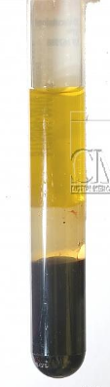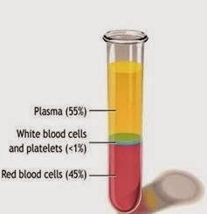

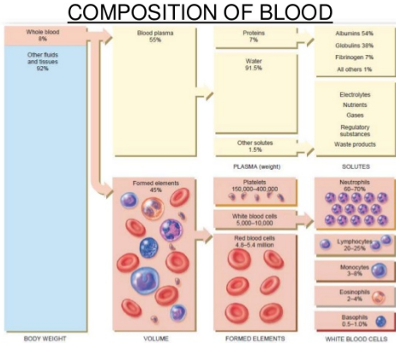

(1). Red blood cells (RBCs)

RBCs are also called Erythrocytes. They are produced by red bone marrow.
Erythrocytes are responsible for transporting oxygen needed for cellular metabolism.
Hemoglobin: an iron-rich protein in RBCs that binds with oxygen (O₂).

Functions:
- Transports O₂, carbon dioxide (CO₂), and hydrogen ions.
- Antigens are found on the surface of RBCs.

(2). White blood cells (WBCs)

WBCs are also called Leukocytes. They play a vital role in healing and immune response.
5 types in 2 broad categories:

(A). Granulocytes: is a category of white blood cells characterized by the presence of granules in their cytoplasm.
- Basophils
- Esosinophils
- Neutrophils
(B). Agranulocytes: is the category of white blood cells that does not contain granules in their cytoplasm.
- Lymphocytes
- Monocytes
  - Granular: in inflammation and tissue healing.
  - Agranular: specific roles in immune response.

(3). Platelets
- They are also called Thrombocytes.
- Produced in red bone marrow.

Hemostasis: process that stops bleeding or blood flow. It is a 3-step process namely:
  - Vascular spasm.
  - Platelet plug.
  - Clot formation.

Pathology Alerts:

In impaired clotting, anticoagulant therapy, blood thinners (like aspirin) are used. Therefore, clients will bruise more easily.

Anemia:

Is not a disease by itself, but an indicator of:
  - Deficiency in amount of hemoglobin.
  - Decreased number or volume of RBCs.
Causes:
- Iron deficiency.
- Bone marrow dysfunction.
- Genetic conditions.
- Active bleeding - Loss of blood through heavy menstrual bleeding or wounds.

Signs and symptoms: fatigue, pallor, other S&S

Manual therapies not contraindicated, but use caution for clients with anemia related to certain causes.

Blood types:

ABO system

Antigens are surface proteins of Red Blood Cells - A & B.

People who have A&B antigens = type AB = Universal Recipients.

People who do not have A or B antigens = type 0 = Universal Donors.

Rh blood group system

Rh+ people have Rh protein on RBCs.

Rh – people do not have Rh protein.

Rh – mothers with Rh+ fetus need to take medications --- especially an issue with 2nd pregnancy (or 3rd, 4th, etc).

The Heart:
- It is the muscular pump that provides primary force to circulate blood.
- Located in mediastinum.
- Surrounded by two-layered pericardium.
Pericardium: the membrane enclosing the heart, consisting of an outer fibrous layer and an inner double layer of serous membrane.
- 3 layers in heart walls:

    - Epicardium - a serous membrane that forms the inner layer of the pericardium, and the outer surface of the heart.
    - Myocardium - the muscular tissue of the heart.
    - Endocardium - the thin, smooth membrane that lines the inside of the chambers of the heart.

Heart Chambers, Great Vessels, & Valves

Heart is divided into right and left sides. Each side has an atrium and a ventricle.
Septum: muscular partition between sides.
Heart has 4 valves:
- 2 AV(Atrioventricular) valves between chambers:
  - Tricuspid valve: right AV valve.
  - Bicuspid or mitral valve: left AV valve.

- 2 Semilunar valves between ventricles and blood vessels:
- Aortic valve
- Pulmonary valve
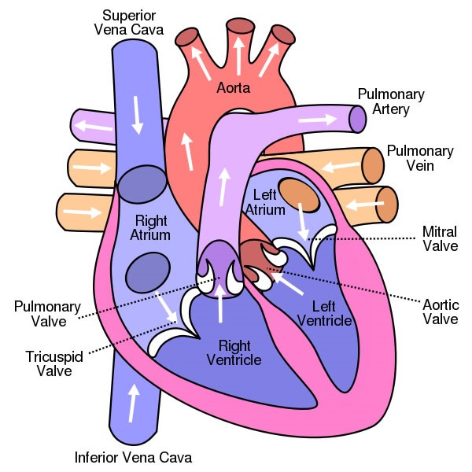

Blood flow through heart:

- From pulmonary veins into left atrium.
- Into left ventricle.
- Pumped through into aorta and throughout body.
- Back through vena cava into right atrium.
- Into right ventricle.
- Pumped into pulmonary artery and to lungs.
- Returns via pulmonary veins.
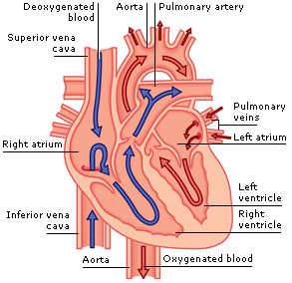

(1). Pulmonary circulation is between heart and lungs. It refers to the circulation of blood in which deoxygenated blood is pumped from the heart to the lungs and oxygenated blood is returned to back to the heart.
(2). Systemic circulation occurs between the heart and the entire body.
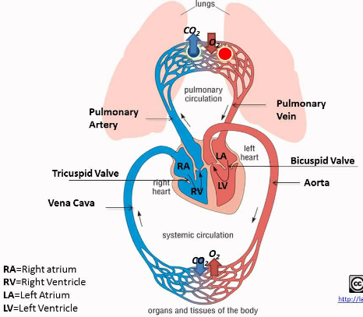

(3). Coronary Circulation: is the system of blood vessels throughout the myocardium that takes care of the metabolic needs of the cardiac muscle tissue.
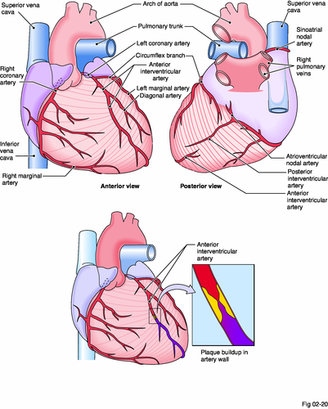

Hearts Conduction System:

- Cardiac conduction system composed of auto rhythmic fibers in heart.
- Sets pace and coordinates contractions of heart.
- Primary components:
- SA node
- AV node
- AV bundle (bundle of His)
- Right and Left branch bundles
- Purkinje fibers.

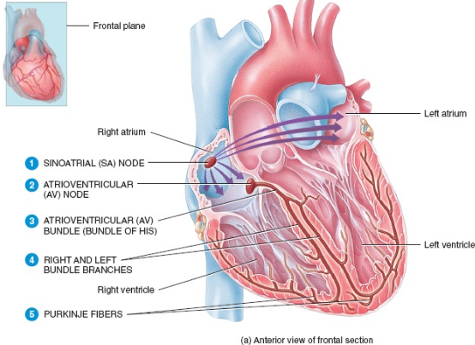

Cardiac cycle: an ordered sequence of atrial and ventricular contraction and relaxation in one heartbeat.
Each cycle = one heartbeat comprising of one systole and diastole.
Systole: (contraction state) refers to the contraction state of heart chambers.
Diastole: (relaxation state) refers to the relaxation state in which the chambers dilate as they fill with blood.
Bradycardia – slow HR < or = 50 BPM.
Tachycardia – rapid HR > or = 100 BPM.

Regulation of Heart Rate:

- Many factors affect individual’s heart rate, which can change much during day
- 3 key regulatory mechanisms for heart rate:
  - Cardiovascular center of medulla oblongata – part of ANS
  - Hormones that increase general metabolic rate
  - Ion levels in the blood (sodium, potassium, calcium)

Blood Vessels:

- Arteries - Move blood away from heart.
- Arterioles – Controls distribution of blood to capillary bed.
- Capillaries – Site for nutrient and waste exchange.
- Venules – Collects blood from capillary bed.
- Veins - Move blood toward heart.
Arteries and veins have:
- Inner epithelial layer
- Middle smooth muscle layer
- External connective tissue layer

Arteries and Arterioles:

- Move blood away from heart.
- Oxygen rich (except pulmonary artery).
- Very elastic walls.
- Three layers (tunics).
  - Tunica interna
  - Tunica media
  - Tunica externa

Capillaries:

- Where exchange of O2 and CO2 takes place.
- Single endothelial layer.
- Thin, permeable membrane.
- Pre-capillary sphincter.
Veins and venules:

- Take blood back to the heart.
- Oxygen poor blood (except pulmonary vein).
- Three lumen (like arteries), but thinner walls.
- Wide lumen.
- Blood reservoir (low pressure – high volume).
Smooth muscle contractions control size of lumen.
- Vasoconstriction: constriction of blood vessel, thereby reducing the size of lumen.
- Vasodilation: dilatation of blood vessel, thereby increasing the size of lumen.
At end of each arteriole an extra ring of smooth muscle called precapillary sphincter.

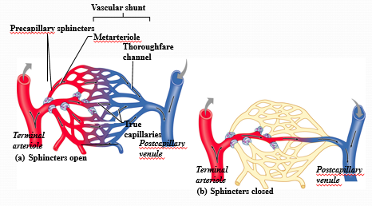
Arterial flow:

Blood flow in arteries influenced by intrinsic factors:
- Ventricular contraction.
- Blood pressure.
- Arterial recoil.
Blood pressure: measurement of hydrostatic pressure of blood against vascular wall
  - Systolic
  - Diastolic

Pathology Alert:
Hypertension:

- High blood pressure: systolic pressure over 140 mm Hg and/or diastolic pressure over 90 mm Hg.
- No consistent symptoms – the “silent killer”.
- Can be sign or cause of vascular or heart disease.

Manual therapy:

  - May be contraindicated when hypertension is sign of cardiovascular disease.
  - Generally indicated for stress-related hypertension.

Clients should check with primary health care provider.

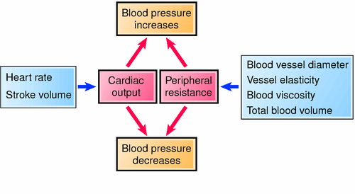
Capillary flow and exchange:

Capillary exchange regulated by 4 diffusion pressures (Starling forces):
- Capillary fluid pressure (CFP).
- Interstitial fluid pressure (IFP).
- Plasma oncotic pressure (POP).
- Interstitial oncotic pressure (IOP).
Capillary exchange in 2 parts: filtration and reabsorption.

Venous Flow:
Venous flow relies on:
  - External compression from skeletal muscle contraction.
  - One-way valves.
  - Respiratory pump.
Pathology Alert:

Heart Attack:

- Myocardial infarction (MI): occurs when coronary blood flow is disrupted. Myocardial tissue death inhibits heart function.
- Causes: atherosclerosis, arteriosclerosis, thromboembolism, acute vasospasm.
- Symptoms may vary between men and women.
- Manual therapy may have precautions due to medications taken by heart attack survivors.

Vein disorders:

Venous conditions manual therapists commonly see:
  - Varicose veins
  - Thrombophlebitis
  - Deep vein thrombosis (DVT)
All present some contraindications or cautions.
If suspected, refer client to health care provider.

Regulation of circulation:

(1). Physiologic mechanisms that regulate circulation by changing blood pressure, vasodilation, or vasoconstriction:
- Autoregulation mechanisms.
- Nervous system regulation.
- Hormone secretions.

(2). Manual therapies not shown to increase systemic circulation.

Inflammation and Tissue Healing:

- Hemostasis and inflammation: initial tissue responses to trauma.
- Inflammation helps stabilize damaged tissue and prepare for repair.
- Key physiologic processes of inflammation:
  - Vasodilation.
  - Changes in capillary permeability.
  - Clot formation.
  - Phagocytosis.

(1). Acute Stage of Healing Process:
- Acute (inflammatory) stage begins when tissue is damaged.
- Hemorrhage and inflammation result in primary edema.
- Leukocytes, phagocytes, fibroblasts.
- Other key physiologic events:
  - Pain and muscle spasm.
  - Secondary edema formation.
  - Hematoma organization.

(2). Subacute Stage of Healing Process:
Subacute (proliferative) stage: tissue repair begins.
  - Reabsorption of leukocytes and phagocytes completed.
  - Number of fibroblasts increased.
  - Granulation tissue laid down throughout hematoma.
  - Collagen remodeling.
Manual therapy can help prevent disorganized repair fibers.

(3). Maturation Stage of Healing Process:
- Continuation and completion of collagen remodeling process.
- Granulation tissue is completely dissolved and recycled.
- Fibrocytes generate new collagen until full tensile strength returns.
Manual therapy helps:
  - Create flexible, well-aligned repair tissue.
  - Improve pain-free range of motion.

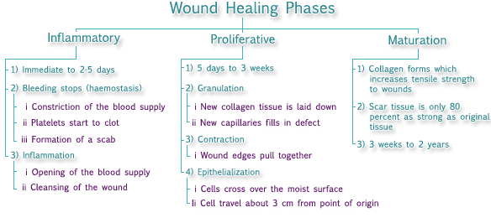

Aging and Cardiovascular system:
Physiologic declines in cardiovascular system with aging:
- Progressive loss in size and strength of heart.
- Reduced blood flow to brain and other organs.
- Blood vessels thickened and less elastic.
- Rising blood pressure.
- Higher incidence of heart disease, atherosclerosis, and arteriosclerosis.

